IMPROVING ACCESS TO HEALTH CARE FOR NEVADA’S UNDERSERVED POPULATIONS:
REPORT ON THE J-1 PHYSICIAN VISA WAIVER PROGRAM
2001-2008

August 2008

Primary Care Office
Bureau of Health Planning and Statistics
Nevada Health Division

Christine Rushing, RN, MPH
Manager, Primary Care Office
Table of Contents

 | Page
Executive Summary | 3
History of the J-1 Visa Waiver and National Interest Waiver (NIW) Programs | 4
Table 1: J-1 Physicians in Nevada: 2001 - 2008 | 4
Table 2: NIW Physicians in Nevada: 2001 - 2008 | 4
Table 3: J-1s Nationwide | 5
Table 4: Decline in J-1 physicians in other states | 6
Possible adverse effect of increasing Conrad 30 cap | 6
Complaints
Table 5: Complaints received from J-1 Physicians and Employers 2001 - 2008 | 7
Table 6: Summary of complaints reported by the Las Vegas Sun | 7
Demographics of J-1 Physicians | 9
Table 7: Country of Birth | 9
Table 8: Name of Provider and # of J-1 Physicians each year – 2001 - 2008 | 10-11
Table 9: County and Town where J-1s were placed – 2001 - 2008 | 11
Table 10: Population to Primary Care Physicians | 12-13
Performance Measures
Table 11: Retention of J-1 Physicians for 3 year commitment | 14
Table 12: Why did the physician leave? | 14
Table 13: Retention of J-1 Physicians 1+ year after commitment in a HPSA | 14
Future of the J-1/NIW Program | 15
Primary Care Action Plan | 16-17


J-1 Physician Visa Waiver Program
Summary Report of Activities 2001 - 2008

The purpose of the Nevada Conrad 30 J-1 Visa Waiver and National Interest Waiver programs is to improve access to health care in underserved areas of the state by increasing the number of physicians who will provide primary care to underserved populations.

In the summer of 2008, the Primary Care Office began an evaluation of the Conrad 30 J-1 Visa Waiver (J-1) and National Interest Waiver (NIW) programs in the following areas: the provision of care to Medicaid recipients, the factors involved in the recruitment and retention of physicians in underserved areas, and the performance of the Primary Care Office (PCO).

The program evaluation used three sources of data: demographic data collected routinely on the J-1/NIW physicians serving in Nevada, aggregate data from Health Care Financing and Policy regarding services provided to Medicaid clients, and the J-1/NIW survey data collected in the summer of 2008. At this time, the Medicaid data and the survey data have not been analyzed. Following are some of the areas that stood-out as successes when analyzing the performance of the PCO.

- 122 J-1 physicians worked for Nevada sponsors in the last seven and one half years
- 87% percent of J-1 visa waiver physicians completed their three years in Nevada.
- 65% of the J-1 visa waiver physicians continue working in Nevada for one year past their commitment.
- Over the last seven years, J-1 visa waiver physicians have successfully increased access to care for the medically underserved populations of Nevada. An example of that success is: In North Las Vegas, the population to physician ratio is 1:5765 without the J-1s included in the calculation; with the J-1s included in the calculation, the ratio is 1:3459.
- The data from Health Care Finance and Policy revealed that a large number of Medicaid recipients receive services from J-1 visa waiver physicians (specifics to follow).

Areas that need improvement:
- Procedures need to be developed to ensure physicians are not abused in their work setting;
- The PCO needs to do better tracking of physicians during and after the program;
- We need to assist employers/sponsors in recruiting and retaining physicians, including facilitation of a statewide workgroup to work on these issues; and
- Establish better collaboration with licensing boards and other partners to speed-up the process for J-1 visa waiver approval.

Several physicians have returned the satisfaction survey. The results will be compiled by September 1, 2008 and the aggregate data will be provided to the Council and other interested parties.

HISTORY OF THE J-1 / NIW PROGRAM

International Medical Graduates (IMG) are physicians who attend medical school and receive their medical degrees outside of the United States. IMGs are allowed to enter the U.S. for graduate medical education, through a J-1 Visa sponsorship, at an accredited residency or fellowship program. After completion of training, IMGs are required to return home for two years before returning to the U.S. under the J-1 visa waiver program. The two-year requirement is waived if the physician is willing to provide full-time primary medical care for three years in a Health Professional Shortage Area (HPSA) or Medically Underserved Area (MUA).

The J-1 program was enacted in 1994 and gave state health departments the authority to make 20 recommendations per year. In 2002, Congress increased the waivers to 30 per year. In 2004, Congress amended the program so that 5 of the 30 slots could be used to treat medically underserved even if the site is not in a designated HPSA or MUA.

Once a J-1 physician finishes their three year commitment at their designated job site, they can apply to the Nevada State Health Division (NSHD) for a National Interest Waiver (NIW) which would allow them to continue to work in a HPSA for an additional two years. A physician may apply and obtain a green card (permanent residency) at the completion of the five years.

J-1 Physicians placed in Nevada

For 2001 and 2002, there were twenty J-1 slots available in Nevada. Starting in 2003, there have been thirty J-1 slots available annually in Nevada. There have been one hundred and twenty-two J-1 physicians “placed” in Nevada in the last seven and one half years – an average of seventeen a year. At this time there are thirty J-1 physicians serving their three year commitment.

% of J-1s placed / allowed | Goal | 2001 | 2002 | 2003 | 2004 | 2005 | 2006 | 2007 | 2008
% of J-1s placed / allowed | 80% of allowed | 20/20 100% | 20/20 100% | 27/30 90% | 18/30 60% | 13/30 43% | 11/30 37% | 9/30 30% | 4 placed, 6 additional possible 10/30 33%
Table 1: J-1 Physicians in Nevada-2001 - 2008

NIW Physicians placed in Nevada

% of J-1s that continue in the NIW Program in Nevada | Goal | 2001 | 2002 | 2003 | 2004 | 2005 | 2006 | 2007 | 2008
% of J-1s that continue in the NIW Program in Nevada | 75% of physicians | 2/20  10% | 15/20  75% | 13/27  50% | 4/18  22% | 1/13  <1%  Physician still on 3 yr commitment | 1/11  <10%  Physician still on 3 yr commitment | 0/9 | 0/10
Table 2: NIW Physicians in Nevada- 2001 – 2008 (note: the denominator is the total # of J-1s placed each year).

It is not clear why there has been a 67% decline in J-1 physicians coming to Nevada since 2003. Following are some of the possible reasons:

- The number of physicians who conduct their residency training on J-1 visas dropped nationwide from 11,600 in 1996 to 6,200 in 2004. Part of this decline, according to the Government Accountability Office (GAO) is that more foreign-born medical students are coming to the U.S. on the less-restrictive H-1B visa, rather than the J-1 visa. The H-1B program does not require three years of service in a HPSA area.
- There has been a slow increase over the last seven years in the annual number of J-1 physicians placed by government agencies in a HPSA area. According to the statistics from the Primary Care Office in Texas, 579 J-1s were placed in 2001 and 694 were placed in 2007. There was a peak year of placement, 2003, with 1033 physicians placed in that year alone.

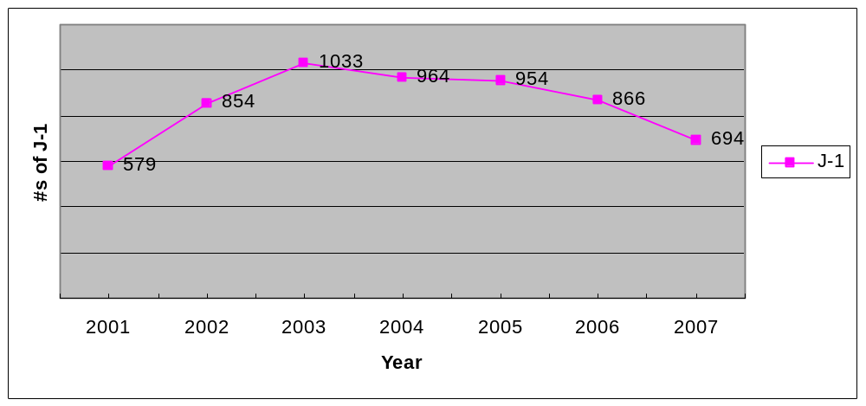

Table 3: J-1s nationwide 2001 – 2007

- Since the 9/11 catastrophe, the screening process for immigration has been more stringent.
- According to an investigation conducted by the Las Vegas Sun, the J-1 program in Nevada is avoided by some foreign physicians because they have heard stories of mistreatment by sponsors. In 2001 and 2002, there were six written complaints from J-1 physicians regarding Nevada sponsors not abiding by the terms of the contract (specifics below). There was one complaint from a sponsor regarding the physician not abiding by the terms of the contract. Since 2002, the Primary Care Office has not received any written complaints from physicians regarding Nevada sponsors. Recently, the Primary Care Office actively solicited feedback from J-1 physicians by sending satisfaction surveys to ninety-eight individuals during July 2008. Those results are not available yet.
- There has been a decline in J-1s placed in several of the other states with populations similar to Nevada. However, two states, Arkansas and Iowa, have managed to attract nearly 30 J-1 physicians a year to their state. The PCO has contacted those particular states to elicit their strategy for recruitment and retention.

Decline among states with similar population

State | Pop | 2001 | 2002 | 2003 | 2004 | 2005 | 2006 | 2007
Arkansas | 2,811,000 | 0 | 30 | 30 | 30 | 29 | 14 | No data
Iowa | 2,982,000 | 20 | 30 | 30 | 30 | 28 | 29 | No data
Kansas | 2,764,000 | 0 | 4 | 14 | 26 | 17 | 17 | 14
Mississippi | 2,911,000 | 14 | 13 | 19 | 17 | 18 | 8 | 9
Nevada | 2,496.000 | 20 | 30 | 27 | 18 | 13 | 11 | 4
Utah | 2,550,000 | 18 | 17 | 4 | 6 | 5 | 4 | 1
Table 4: Decline in J-1s in other states

- Following are the states that successfully placed all available J-1s each year since 2001: Arizona, California, Illinois, Kentucky, Massachusetts, Michigan, Missouri, North Carolina, Texas and Washington.

Possible Adverse Effect of Congress Raising the Conrad 30 Cap

- Congress is considering raising the cap for J-1 physicians by five for each state. In order for states to take advantage of the increase, 1350 (90%) of the approximately 1500 slots would have to be filled before the states that have filled their quota can add five more. Ten states fill their quota rather quickly; the other 40 states would have to fill 26 of their 30 slots before the cap increase would take effect for the nation. Approximately 700 J-1s were placed in 2007, an average of 14 per state. In the “boom” year of 2003, 1033 physicians were placed, an average of 21 per state. The conclusion of the Primary Care Office is that an increase of the cap will not significantly affect Nevada’s efforts to recruit and retain J-1 Physicians, at least in the next several years.

COMPLAINTS

Written Complaints submitted to the PCO from 2001 - 2008

2001 | Physician did not finish 3 year commitment. The physician did not like the working conditions at the first designated site. He alleged that there was no functioning clinic in the designated site. The physician was assisted in moving to another HPSA clinic where he worked a short time; the physician subsequently returned to India due to personal reasons. The original sponsor is no longer in business.
 | Two physicians with the same sponsor finished their 3 yr commitment in Nevada. The physicians alleged that the original sponsor made the physicians work at clinics that were not underserved and for a HMO. They alleged that there was a significant delay after receiving notice of H-1B approval and being able to work because the employer did not have money to pay them. They alleged that their employer falsified documents to the State. The PCO successfully assisted the physicians in finding other sponsors. The original sponsor is no longer in business.
 | The physician did not finish the 3 yr commitment in Nevada; she moved to Utah. The physician alleged that she was made to work at Centers that were not underserved. The physician was not paid for a period of time and did not receive the promised health benefits. The sponsor tried to get the physician to take a $100,000 loan out for the clinic. The sponsor is no longer in business. The Office of the Attorney General was notified by the PCO.
 | The physician did not finish the 3 yr commitment in Nevada; he moved to Georgia. The physician alleged that he was forced to work at sites that were not part of the contract, that he was not paid the salary that was agreed upon in the contract, and that he was forced to provide a $150,000 loan to the clinic.
2002 | The physician did not finish the 3 year commitment. Physician alleged that his sponsor tried to force him to work in San Bernardino and that there were other Nevada J-1s that were working in San Bernardino for the employer. The physician quit the practice and moved to another state. No evidence of intervention by the PCO. The employer is no longer in business.
 | The physician finished the 3 yr commitment in Nevada. A co-worker alleged that this particular physician was working in San Bernardino instead of the designated HPSA site in Nevada and falsifying documents to the State. No evidence of intervention by the PCO. The employer is no longer in business.
 | The physician finished the 3 yr commitment in Nevada. The employer/sponsor alleged that the J-1 physician refused to perform the contractual functions such as diagnose, treat and help prevent disease and injuries. The physician was subsequently terminated by the sponsor and sued for damages. The PCO assisted the physician to find another placement.
2003 - 2008 | No formal complaints
Table 5: Complaints received from J-1 Physicians and Employers, 2001 - 2008

Summary of complaints reported by the Las Vegas Sun

During 2007, the Las Vegas Sun published an extensive investigation regarding mistreatment of J-1 Visa Waiver physicians by their sponsors/employers. The following table illustrates the different areas of mistreatment. Physicians requested that their names not be publicized in the Las Vegas Sun because of fear of retribution.

Employer | Didn’t pay | Over 40 hrs / exhaustion | Threatened Deportation/ Firing | Changed Contract | Physician didn’t work in HPSA/MUA | Non-compete clause | Loan to employer mandated | Business Financially unstable | Falsified Records
#1 |  |  |  |  | X |  |  |  | X
#2 |  | X | X |  | X |  |  |  | X
#3 |  | X | X |  | X | X |  |  | X
#4 | X | X | X | X | X |  | X | X | X
Table 6: Summary of complaints reported by the Las Vegas Sun

Please refer to the Action Plan at the end of the report for the actions that the Primary Care Office has developed regarding complaints from J-1 physicians and employers. At the present time, the PCO is attempting to contact the sponsors identified in the Las Vegas Sun articles to determine if there has been a resolution to the problems identified by the J-1 physicians. More information will be provided to the Council and interested parties in the next several months.

DEMOGRAPHICS

Country of Birth
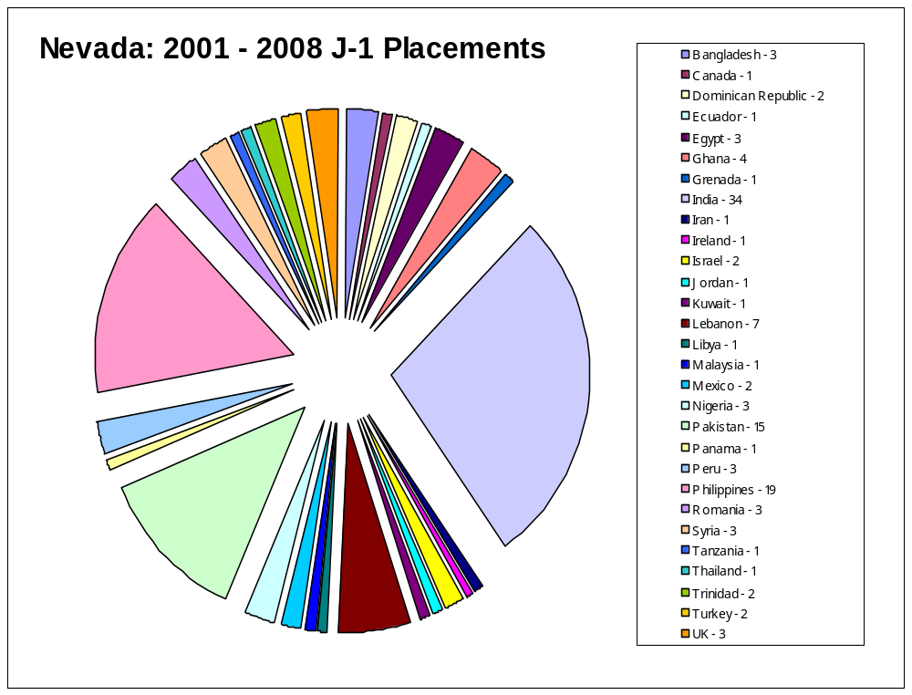
India - 34
Philippines - 19
Pakistan - 15
Table 7: Country of Birth
Total: 122
Sponsor / Providers Names

Sponsors / Providers |  | 2001 | 2002 | 2003 | 2004 | 2005 | 2006 | 2007 | 2008 | Totals
Advanced Medical | Pahrump | 1 |  |  |  | 1 | 1 |  |  | 3
Anju, Seema | NLV |  |  | 2 |  |  |  |  |  | 2
Apex Med. Cntr | LV |  |  |  | 2 |  | 2 |  |  | 4
Battle Mnt Rural Health Cntr | Battle Mtn |  | 1 |  |  |  | 1 |  |  | 2
Cambridge Family Health Cntr | LV |  |  | 1 |  |  | 1 |  |  | 2
Carlin Health Cntr | Carlin |  | 1 |  |  |  |  |  |  | 1
Centennial Hills | NLV |  |  |  |  | 1 |  |  |  | 1
Comprehensive Med. Cntr | LV |  |  |  | 1 |  |  |  |  | 1
Crescent Medical Assoc | LV |  |  | 1 |  |  |  |  |  | 1
Desert Oasis | Laughlin |  |  |  |  |  |  | 1 |  | 1
Desert Pediatrics | LV |  |  |  |  |  | 1 |  |  | 1
Desert View Region Med Cntr | Pahrump |  |  |  |  | 1 |  |  |  | 1
AC Dionisio | NLV |  |  |  |  |  | 1 |  |  | 1
Edwards, Larry | LV |  |  |  |  |  |  |  | 1 | 1
Eastern Sierra Med | Silver Sprg |  |  |  |  | 1 |  |  |  | 1
El Dorado Medical Center | NLV | 3 | 7 | 3 | 2 | 2 | 1 | 2 |  | 20
Elko Family Medical | Elko |  |  |  |  | 1 |  |  |  | 1
Eureka Med Cntr | Eureka |  | 1 |  |  |  |  |  |  | 1
Family Health /Sterling Med | LV |  |  | 1 |  |  |  |  |  | 1
Gastroenterology Cntr NV | NLV | 2 |  |  | 1 |  |  |  |  | 3
Guadalupe Med Cntr | NLV | 1 | 1 | 1 | 1 | 1 |  |  |  | 5
HAWC | Reno |  |  | 2 |  |  |  |  | 2 | 4
Health Care Center | NLV | 3 | 2 | 2 | 1 |  |  |  |  | 8
Health Partners of NV | NLV |  |  |  |  |  |  | 3
Infectious Disease Specialists | NLV |  |  |  |  |  |  |  | 1 | 1
Kappellini Med Inc | LV |  |  | 1 | 1 |  |  |  |  | 2
Kordstrebl
Lake Mead Cntr | NLV |  |  | 1 |  |  |  |  |  | 1
Las Vegas Outreach Cntr | LV |  |  |  |  |  | 1 |  |  | 1
Las Vegas Pediatrics | LV |  |  |  |  | 1 |  |  |  | 1
Mesquite Med Assoc. | Mesquite |  |  | 1 |  |  |  |  |  | 1
Mohave Mental Health | Reno |  |  | 1 |  |  |  |  |  | 1
Mt. Grant Hosp. | Hawthorne | 1 |  |  |  |  |  |  |  | 1
NNAMHS (State Mental) | Reno |  |  |  | 1 |  |  |  |  | 1
NV Children’s Clinic | Reno | 1 |  |  |  |  |  |  |  | 1
NV Health Cntr (NHC) | Beatty | 1 |  |  | 1 |  |  |  |  | 2
NHC | Gerlach | 1 |  |  |  |  |  |  |  | 1
NHC | LV |  |  |  |  |  |  | 1 |  | 1
Overton Urgent Care | Moapa |  |  |  | 1 |  | 1 |  |  | 2
Owyhee Health Facility | Owyhee |  | 1 |  | 1 |  |  |  |  | 2
Parikh, Nutan | Pahrump |  |  |  | 1 |  |  |  |  | 1
Physician’s Health Net | LV |  |  |  |  | 1 |  |  |  | 1
Primary Care Med Group | Pahrump |  | 2 |  |  |  |  |  |  | 2
Pulmonary Assoc. | NLV | 1 |  |  |  |  |  |  |  | 1
Red Rock Med Group | LV |  |  | 1 |  |  |  |  |  | 1
Redrock Pahrump Cntr | Pahrump |  |  | 2 | 2 | 1 |  | 1 |  | 6
SNAMHS (State Mental) | LV |  |  |  | 1 |  |  |  |  | 1
Southwestern Urology PC | NLV |  |  | 1 |  |  |  |  |  | 1
South Lyon Med Cntr | Yerington |  | 1 |  |  |  |  |  |  | 1
Specialty Med Cntr | Pahrump | 2 |  |  |  |  |  |  |  | 2
Summit Med Cntr | NLV | 3 | 3 | 4 |  |  |  |  |  | 10
Super Medical Cntr | NLV |  |  | 1 |  |  |  |  |  | 1
Trucare Med Cntr | NLV |  |  |  | 1 |  | 1 |  |  | 2
UNLV – Internal Med | LV |  |  |  |  |  |  | 1 |  | 1
Vega, Paul | NLV |  |  | 1 |  | 1 |  |  |  | 2
Villaluz Clinic
Virgin Valley Med | Mesquite |  |  |  |  | 1 |  |  |  | 1
 |  |  |  |  |  |  |  |  |  | 122
Table 8: Name of provider and # of J-1 physicians each year

County and Towns in Nevada where J-1s were placed
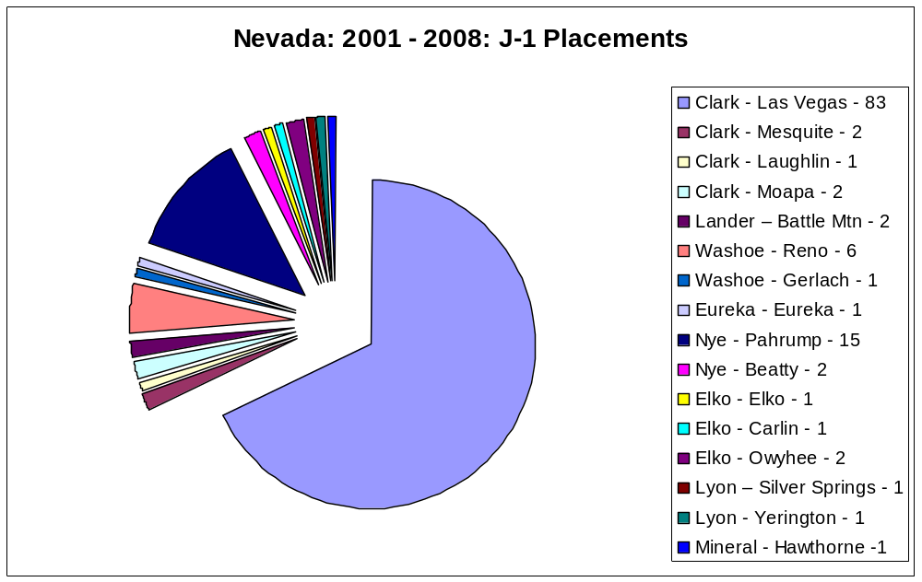

Pahrump - 15

Las Vegas – 83 (68%)
Las Vegas - 83

Total 122
Total = 122

Table 9: County and Town where J-1s were placed

The following spreadsheet represents the latest Health Professional Shortage Area (HPSA) calculations submitted to Heath Resource and Services Administration (HRSA). To qualify as a geographic HPSA, the population to primary care provider ratio (not just physicians) must be greater than 1:3000.

Please note that the county population is based on the 2000 census data. However, the total populations for Clark and Washoe are 2007 estimates.

The full time equivalent (FTE) for primary care physicians (PCP) working in each county was based on information obtained from the Nevada Board of Medical Examiners and the Center for Education and Health Services Outreach (University of Reno). The PCP fulltime equivalent has been adjusted per HPSA guidelines, which excludes physicians working for the Federal government, physicians in the National Health Service Corp (NHSC), state loan re-payers, and J-1 visa waiver physicians.

For Clark and Washoe County, the number of providers was obtained from the Board of Medical Examiners and is estimated. The subcategories are health shortage areas only and when added together do not equal the total county population.

County/Area | Current HPSA  Designation | Renewal Date | County Population | Primary Care Physician FTE | Pop: PCP Ratio | Government Physicians (not included in ratio)
Carson City | Governor Designated | N/A | 52457 | 24 | 1:2186 | 1
Churchill | N/A | N/A | 23982 | 20 | 1:1199 | 0
Clark | N/A | N/A | 1,836,333 (2007 estimate) | 1264 | 1:1453 | 0
Clark – Cambridge | Low Income | 8/2009 | 99922 | 14 | 1:7137 | 4
Clark – Indian Springs | Geographic | 11/2008 | 8058 | 0 | 0:8058 | 0
Clark – Las Vegas Metro | Low Income | 5/2010 | 52760 | 0 | 0:52760 | 1
Clark – Laughlin | Geographic | 4/2009 | 12552 | 1.5 | 1:8368 | 0
Clark – North Las Vegas | Geographic | 3/2008 | 155646 | 27 | 1:5765 | 28
Clark – Overton | Geographic | 6/2009 | 9247 | 3.4 | 1:3720 | 3
Clark – Mesquite | N/A | N/A | 7354 | 5 | 1:1471 | 3
Clark – Sunrise | Low Income | 2/2008 | 61254 | 0 | 0:61254 | 1
Douglas | Doesn’t qualify | N/A | 41259 | 32 | 1:1289 | 0
Elko – City of | Governor Designated | N/A | 45291 | 18 | 1:2516 | 5
Elko – Eastern | Geographic | 5/2010 | 8575 | 0 | 0:8575 | 2
Elko – Northern | Geographic | 5/2010 | 1544 | 1 | 1:1544 | 0
Esmeralda | Geographic | 8/2010 | 971 | 0 | 0:971 | 0
Eureka | Geographic | 8/2010 | 1651 | 0 | 0:1651 | 1
Humboldt | Geographic | 6/2008 | 16106 | 6.8 | 1:2369 | 0
Lander | Geographic | 5/2009 | 5794 | 0 | 0:4165 | 2.1
Lincoln | Geographic | 6/2008 | 4165 | 1 | 1:4165 | 0
Lyon | Geographic | 3/2008 | 34501 | 9 | 1:3833 | 0
Mineral | Geographic | 4/2009 | 5071 | 3 | 1:1690 | 0
Nye | Geographic | 4/2009 | 32485 | 16 | 1:2030 | 3
Pershing | Geographic | 9/2009 | 6693 | 1 | 1:6693 | 0
Storey | Geographic | 11/2008 | 3399 | 0 | 0:3399 | 0
Washoe | N/A | N/A | 406079 (2007 estimates) | 307 | 1:2323 | 0
Washoe – Gerlach | Geographic | 4/2009 | 499 | 0 | 0:499 | 1
Washoe – Reno/Sparks | Low Income | 4/2009 | 87203 | 39 | 1:2236 | 3
Washoe-HAWC | CHC/Facility |  | 15983 clients | 0 |  | 2
White Pine | Low Income | 4/2009 | 9181 | 8 | 1:1148 | 0
Summary |  |  | 2,535,537 | 1800.7 | 1:1409 | 60.1
Table 10: Population to Primary Care Physician Ratios

What conclusions can we draw from Table 10?

- Following are County/Areas that may lose their HPSA geographic designation on their next renewal date: Nye County which includes Pahrump; Humboldt County which includes Winnemucca; Mineral County which includes Hawthorne; and White Pine County which includes Ely. The PCO is partnering with the professional licensing boards, Great Basin Primary Care Association, the University of Nevada and other partners to formulate a more accurate, consistent method to determine the FTEs of primary care providers providing services in Nevada. Along with using Nevada’s population data from the State demographer’s (rather than using outdated 2000 census data), having an accurate assessment of providers in each county will ensure that the HPSA designations give us the information that we need for planning.

- Efforts to qualify new facilities for J-1 physician placement will begin first in areas that have a high population to provider ratio such as Las Vegas Metro, LV Sunrise area, Eastern Elko (Wendover), and Pershing County which includes Lovelock.

PERFORMANCE MEASURES

RETENTION: NEVADA J-1 PHYSICIANS THAT COMPLETED THE 3 YR COMMITTMENT

% of J-1s that completed 3 yr commitment in NV | Goal | 2001 | 2002 | 2003 | 2004 | 2005 | 2006 | 2007 | 2008
% of J-1s that completed 3 yr commitment in NV | 90% | 17/20 85% | 18/20 90% | 24/27 89% | 15/18 83% | 2/13  11 still working | /11  10 working | /9  9 still working | /10
Table 11: Retention for 3 year commitment

Why did the physicians leave?

2001 – 3 quit or unknown | - Three quit because of bad working conditions. Three written complaints (CPTs) submitted to PCO.
2002 – 2 quit or unknown | - One quit because of bad working conditions. Written CPT submitted to PCO.  - One unknown status.
2003 – 3 quit or unknown | - Two received waiver – did not show up for work.  - One unknown status.
2004 – 3 quit or unknown | - One moved to Delaware – no reason documented.  - One received green card – moved to Tennessee – no reason documented  - One received waiver – did not show up for work.
2005 – none quit
2006 – 1 quit | - One moved to Virginia – no reason documented.
Table 12: Why did physicians leave?

RETENTION OF PHYSICIANS FOR ONE YEAR AFTER COMMITTMENT

% of J-1s that remain in an underserved area in NV after 3 yr commitment | Goal | 2001 | 2002 | 2003 | 2004 | 2005 | 2006 | 2007 | 2008
 | 75% | 15/20  75% | 14/20 70% | 17/27  63% | 9/18%  50% | 2/13 so far, 10 still on first 3 yrs
Table 13: Retention of physicians for one year in underserved area (Note: the denominator is the number of J-1 physicians that were given a waiver in Nevada.)

The PCO has developed the following preliminary Performance Indicators for the J-1 Physician Visa Waiver Program; data is not available for some of the indicators at this time, but is being collected.
1. # of J-1s placed each year
# of primary care physicians
# of specialists
2. # and % of J-1 physicians that applied but were not approved by the Health Division.
3. % of J-1s that complete the 3 year commitment in Nevada
4. % of J-1s that remain in underserved area for one year after completion of their 3 year commitment
5. Length of time in days for Heath Division to process application – from receipt to sponsor letter to DOS (Department of State).
6. Length of time between DOS notice to start-of-work for physician
7. # of J-1 curriculum vitae sent out annually to providers
8. % of J-1s that report satisfaction with the J-1 experience on the exit survey and/or annual survey.
9. % of employers that report satisfaction with the J-1 experience on the exit survey and/or annual survey.
10. % of Medicaid served – based on semi-annual report average and data from Medicaid.
11. % of sliding fee clients served by active J-1 physicians based on semi-annual report.

FUTURE OF THE J-1 / NIW PROGRAM

- During the next Federal fiscal year, the PCO will continue to collaborate with our partners to conduct a current needs assessment in Nevada regarding access to primary care.

- The PCO plans to develop marketing materials to distribute to immigration lawyers and facilities in Nevada that provide primary care to the uninsured and underinsured.

- The J-1 physician survey will be distributed yearly and the results compiled and presented to the Council for review and feedback. A Corrective Action Plan will be developed by the PCO at the direction of the NSHD Administrator or the Council regarding the survey results.

- As conditions improve at the sponsor site, the PCO anticipates that more J-1 physicians will come to Nevada for their three year commitment.
ACTION PLAN

Responding Agency: Primary Care Office Date response due:
Response prepared by: Christine Roden, Manager Signature:
Date of Review: July 2008 Telephone #: 775 684-4041

Recommendation - Goal | Agency Action Plan | Position Responsible | Date of completion &/or expected completion
1. Develop a process to ensure that physicians are not abused in their work setting. | - A seven member Primary Care Advisory Council was created to review employer/sponsor applications as well as J-1 applications.  - By-laws were developed by the Primary Care Office (PCO) and approved by the Council.  - The quarterly meeting of the Council follows open meeting laws to ensure a transparent approval process.. J-1 physicians are invited to the meetings as well as other interested parties.  - The State created a Web site for the foreign physicians to file complaints anonymously; there have been no complaints since its inception. In July 2008, ninety-eight satisfaction surveys were mailed to J-1s - past and present participants. In the mailing, J-1 physicians were given an invitation to the upcoming Council meeting.  - Draft Policies and Procedures for the J-1 Program have been developed which include:  - The processing of complaints;  - protocol for reporting consumer safety issues and physician abuse to Board of Medical Examiners, Department of State, and Homeland Security;  - conducting exit interviews with physicians and employers to assess satisfaction with the program;  - pre-authorization of new employer sites;  - monitoring of Medicaid services provided at employer sites;  - transfer of a J-1 physician from a site that is not abiding by the program requirements;  - reporting of activities that affect consumer safety to appropriate authorities (Bureau of Licensure and Certification);  - and the reporting of alleged abuse to the Medical Board of Examiners, the Department of State and Homeland Security.  - The Primary Care Office has developed Performance Indicators to guide them in improving the following processes: 1) the length of time the PCO takes to process applications; 2) tracking the status of J-1 and NIW physicians during and after the program; 3) tracking of required reports from the employer and physician; 4) tracking curriculum vitas that are sent to employers and the status of applicants; and 5) tracking of physicians that transfer to another site within the State.  - The Primary Care Office will develop an orientation manual for employers and physicians and conduct a one hour orientation when new physicians start or new employers/sponsors are brought on to the program.  - The PCO will develop a method to evaluate J-1 physician’s adherence to the requirements regarding provision of care at approved site and provision of services to the underserved.  - Develop and implement scheduled and unscheduled site visits and/or audits, and employing specific, uniform criteria for assessing compliance.  - Hold confidential meetings with all J-1 Visa Waiver Physicians.  Ninety-eight J-1 physicians were contacted in 7/08, by email or by postal mail in an effort to elicit anonymous or identified complaints or comments.  Due to resource limitations, face-to-face meetings are not possible at this time with all J-1 physicians.  - The PCO will contact the sponsors/employers that were identified in the Las Vegas Sun articles as “abusive” to elicit the status of the physician complaints about their practices. | Lynn O’Mara, Program Manager, Health Planning  Lynn O’Mara  Christine Roden, Manager, Primary Care Office  Lynn O’Mara  Christine  Lynn O’Mara, Doug Schrauth and Christine Roden  Chris Roden  Chris Roden  Lynn O’Mara and Chris Roden  Chris Roden  Lynn O’Mara  Chris Roden  Chris Roden | Completed April 8, 2008  Approved 4/11/08  Completed: Qtrly meeting: 4/11/08  6/12/08  Next 8/7/08  Draft  Expected Date of Completion: 9/1/08  Draft  Expected Date of Completion: 9/1/08  Implementation: 10/1/08  Completed 7/1/08 ongoing  Site visits as needed and as resources allow  August 1, 2008
2. Maintain tracking of J-1 physicians | - Develop and maintain spreadsheets to track the application process through the Primary Care Office (PCO).  - Ensure that six month reports from employers and physicians are submitted to PCO.  - Implement a requirement for six month reports to be notarized by employer and physician.  - Maintain the following information in existing database and individual physician file: physician email, accurate work site information, date of Department of State notification, and date the physician started work at designated site.  - Assist the physician to notify Department of State & Homeland Security when they transfer to another employer or do not start work within 90 days. | Doug Schrauth  Doug Schrauth  Doug Schrauth  Doug Schrauth  Christine Roden | Completed 7/1/08. Ongoing maintenance  Ongoing  10/1/08  Ongoing  Ongoing
3. Assist facilities in recruiting and retaining J-1 physicians | - Prepare a spreadsheet of curriculum vitae to distribute to prospective employers/sponsors twice a year.  - Develop a marketing brochure to distribute to immigration attorneys.  - Redesign web site for use as resource site for J-1s looking for placement. Ensure that providers/sponsors post their job openings on web site and the web site is kept up-to-date. | Doug Schrauth  Lynn, Chris and Doug  Tasha Gardner | Each March and September  12/1/08  9/1/08 and ongoing
4. Facilitate a statewide Primary Care Development Group | - PCO will facilitate quarterly meetings of internal and external stakeholders. | Judi Corrado and Chris Roden | First meeting planned August, 2008
5. Cooperation with Licensing Boards | - Meet with Board of Medical Examiners to discuss allegations of employers abusing J-1 physicians or not complying with federal program requirements.  - Once J-1 protocols and procedures are finalized and all sponsors and physicians have been informed of requirements, the Board of Medical Examiners will be notified of non-compliance or abuse. | Lynn O’Mara | Meeting on 6/17/08  ongoing
Develop Memorandums of Understanding with physicians and employers | After consultation with the Attorney General’s office, this procedure was determined to be unnecessary. | NA | NA

Sources: Bureau of Health Planning and Statistics: Individual physician files 2001 -2008
Doctors Exploited; patient suffer too. Marshall Allen. Las Vegas Sun.
International Medical Graduates in the U.S.: Trends and Statistics. Ellie Fitzpatrick and Tracy Wallowicz. AHME, Spring 2008
Texas Primary Care Office: Accounting of J-1s placed in each State, 2001 – 2007.

